Online Employment Application Guide
This guide describes how to apply for jobs using the LA Careers website. The process consists of the following steps:

- Create an Account
- Find Jobs
- Apply for a Job

Create an Account

Follow these steps to Sign In:
- Point your web browser to https://www.governmentjobs.com/careers/louisiana.
- Click the in the upper right part of the page.
- If you have already created a user account, log in using your previously created username and password. Otherwise, click ‘Create an account’ to create one, and then enter your new account information.
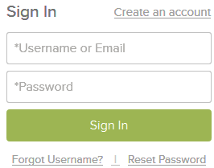
- If you created an account before, you cannot use the same email address again to create a new account. The email value must be unique.
- If you created an account before and can’t remember your username, click on ‘Forgot Username’. This sends you an email with your username.
- Click ‘Reset Password’ if you have forgotten your password.
- Your password must be at least eight characters in length, and contain at least one uppercase letter, one lowercase letter, one number and one symbol (* & %, etc.).
- As you supply correct information for each field, a checkmark on the right indicates that the value is correct. See the next example.

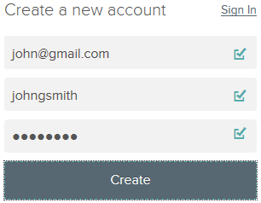

- Click ‘Create’.
Keep a record of your username and password!
When you are signed in, your username appears on the right in the top menu bar:

If you need to change your password while logged in, use ‘Accounts Settings’ in the pulldown menu below your username.

Find Jobs
There are two primary ways to search for jobs:
1. Go to https://www.governmentjobs.com/careers/louisiana and set the filters which match your interests.

You can filter current announcements by Location, Department, Job Category and Salary.
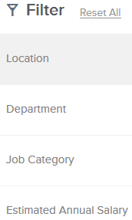
NOTE: Only current vacancies are displayed here.
- Place a checkmark in the box next to the criteria matching your interest(s) and the system will automatically display the current vacancies matching your selection(s).
- The current vacancies matching your search will be displayed alphabetically by job title. You can change this by clicking the sort button. Click the job title link to open the job announcement.
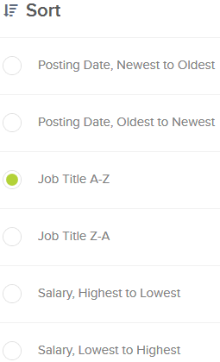

- The other way to quickly find job listings is to type key words into the search box. As you type, the system will find vacancies matching the words entered.

NOTE: Be aware of the “Job Type” listed:
- Classified = open to all applicants
- Promotion = open to permanent classified state employees ONLY
- Unclassified = not part of the classified service
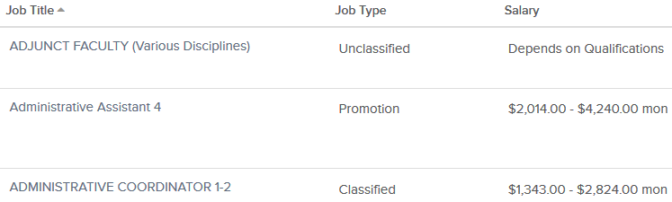

Apply for a Job
- After viewing the job announcement, click the ‘Apply’ button on the right if you would like to apply for the job.
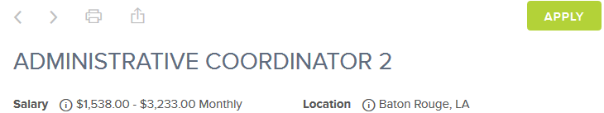
If you are already logged in, you will be taken to the application process (below). If you are not logged in, you will be prompted to sign in.
- Enter your personal information. You can also quickly complete basic profile information by importing a resume from LinkedIn, or by uploading a file.
3. Next, you will complete a series of steps (entries or screens). Your progress and current step in the process is shown on the left. In the example below, the Information step is complete and the Education step is in progress:
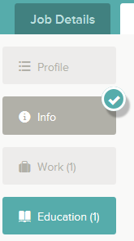
As you work on your application, refer to the progress bar to see the number of items for each entry, and any errors. In the example below, the Work entry contains three items, and the Questions entry contains errors.
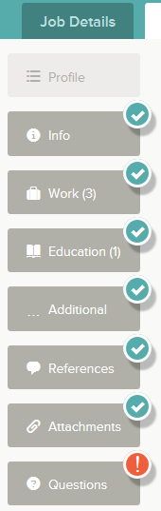

- For each step, the ‘Add’ buttons at the top allow you to enter more information.
- ‘Save’ and ‘Cancel’ buttons on the bottom allow you to save or discard your work on this entry.

Although your typing is periodically automatically saved, it is a good practice to click on the ‘Save’ button. The ‘Cancel’ button discards any changes you have made since the last save.

For some entries, a ‘Remove’ link is present. It deletes the current entry after a confirmation. Once deleted, the data cannot be recovered.

- In the Info section, provide general contact information.
- In the Work section, provide all previous work experience information.
- In the Education section, provide your educational information.
- In the Additional Info section, provide information such as certificates, licenses, skills, and languages.
- In the References section, provide references if required by the posting.
- In the Attachments section, upload any attachments such as a cover letter, occupational license, or college transcripts. The supported file formats are displayed on the Attachments page. To upload files, you must first select the ‘Add supplemental attachment’ button, and then choose the attachment type. NOTE: Once you have successfully uploaded an attachment, it is available when applying for other vacancies. After selecting the ‘Add supplemental attachment’ button, and then choosing the attachment type, click on the clock icon and previously uploaded documents can be selected. See below.
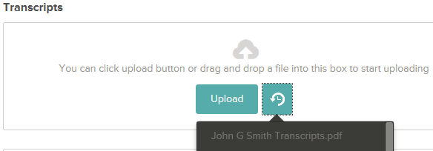

- Answer the Agency questions and the job-specific Supplemental questions. Depending on the job announcement, there may or may not be any supplemental questions to answer.
- Review each section. If there is an error, it is shown in the progress bar and also in the section.
- Use to open this item and correct any errors. Once you have reviewed all sections and corrected any errors, click ‘Proceed to Certify and Submit’.

- If your application is complete and you are ready to submit, click the ‘Accept & Submit’ button. If you need to go back, click the ‘Decline’ button.

An Application Submitted message confirms that you have applied for the job. You will also receive an e-mail confirming your submission. You can check on the status of your application by clicking on ‘Job Applications’ in the top menu bar under your name. Your username also indicates the number of in-progress and complete applications.

For any technical problems with your account, please call governmentjobs.com toll-free at 1-855-524-5627.

